Biological Weapons and Existential Risk

In the history of human civilization, biological weapons have always played a role in wars. One of its early records of use could be dated back to 1155, with Holy Roman Emperor Barbarossa poisoning water wells using human corpses in Tortona, Italy ([1](https://www.ncbi.nlm.nih.gov/pmc/articles/PMC1326439/)). However, it was only after World War I that the biological arms race began and more research programmes on biological weapons were set up. The industry particularly bloomed during World War II, and it is always thought that humans were fortunate enough that most of those destructive weapons were never used. Since biological weapons have such a long history, it is worthwhile to prompt into the questions: what exactly are biological weapons, why are they so powerful, and how are they related to existential risk?

Biological warfare, sometimes also known as “germ warfare”, refers to the manufacture, modification, and release of microorganisms such as viruses, bacteria and fungi with the intention to inflict diseases and death among humans, animals and plants ([2](https://www.who.int/health-topics/biological-weapons#tab=tab_1)). Biological weapons can also be toxic substances produced by living organisms ([2](https://www.who.int/health-topics/biological-weapons#tab=tab_1)). Some biological agents used in the past include *Bacillus anthracis*, which causes Anthrax, *Variola major*, which causes smallpox, *Yersinia pestis*, which causes plague, and others ([1](https://www.ncbi.nlm.nih.gov/pmc/articles/PMC1326439/)). Biological weapons use different mechanisms to deliver the contaminants. Missiles, bombs, hand grenades and rockets were some of the common ways ([3](https://www.un.org/disarmament/biological-weapons/about/what-are-biological-weapons/)). Biological agents can also be contained in aerosol sprays, mixed into food and water, included in injection systems and delivered by vectors such as insects ([3](https://www.un.org/disarmament/biological-weapons/about/what-are-biological-weapons/), [4](https://www.jhsph.edu/research/centers-and-institutes/johns-hopkins-center-for-public-health-preparedness/tips/topics/Biologic_Weapons/BioWeapons.html)).

Biological weapons are dangerous not only because they can lead to mass casualties, but also because the outcomes can be dramatic. Highly contagious biological agents are never restricted to national borders and could spread around the globe rapidly. Damages to agriculture and livestock may result in the imbalance of the ecosystem, possible starvation, and economic losses. Even only manufacturing those weapons can be harmful as laboratory leaks might happen.

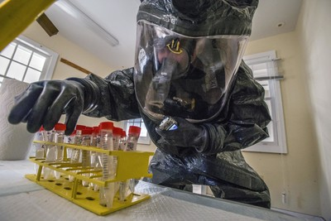

Figure (5)

To have a better idea of the potential destruction, it was found that out of the >500 million people who died of infectious diseases in the past century, several tens of thousands of these casualties were results of deliberate releases of pathogens or toxins ([1](https://www.ncbi.nlm.nih.gov/pmc/articles/PMC1326439/)). It is not hard to imagine the difficulty of controlling a disease as we are all still experiencing the effects of the COVID-19 pandemic in 2022 which started in 2019. For context, by the end of July 2022, COVID-19 has accumulated a number of 577 million cases worldwide, and has taken more than 6.3 million lives ([6](https://news.google.com/covid19/map?hl=en-CA&mid=%2Fm%2F02j71&gl=CA&ceid=CA%3Aen)). It also brought a serious economic recession to the globe in 2020 and has created a lot of closed-down shops and unemployed people ([7](https://www.worldbank.org/en/news/press-release/2020/06/08/covid-19-to-plunge-global-economy-into-worst-recession-since-world-war-ii)). Although measures such as travel restrictions and social distancing have been put in place to deter the transmission of the virus, it was non-stoppable and soon spread from one country to another. Therefore, it can be reflected that if biological weapons were used, it would put a great risk on the existence of human beings.

The case of the Gruinard Island is another good example to illustrate the destructiveness of biological weapons. During World War II, this Scottish island was being used by Britain to conduct experiments on its Anthrax weapons. Since then, it has become contaminated with the disease-causing bacteria and is still uninhabited and prohibited from public access to ensure the safety of public health ([8](https://www.bbc.com/news/uk-scotland-60483849)).

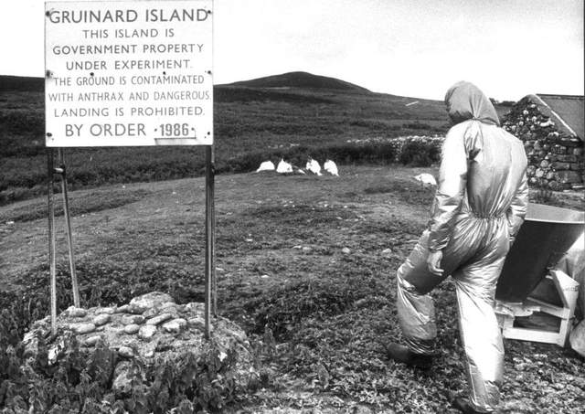

Figure (9)

Considering the potential public health catastrophe they can trigger, biological weapons are being classified as one of the “weapons of mass destruction”, and efforts have been made to achieve the disarmament of those weapons (10). The first international treaty related to biological weapons, the 1925 Geneva Protocol, prohibited the use of chemical and biological weapons in war ([11](https://www.un.org/disarmament/wmd/bio/1925-geneva-protocol/)). However, it did not forbid the storage and preparation of such weapons, which became one of its shortcomings, leading to the massive development of biological weapons before and during World War II. Several countries had also violated the treaty and used biological weapons after the agreement, such as the dropping of ceramic bombs full of plague-infested fleas on a Chinese city by Japan during World War II ([1](https://www.ncbi.nlm.nih.gov/pmc/articles/PMC1326439/), [12](https://www.ncbi.nlm.nih.gov/pmc/articles/PMC8300139/)). Therefore, a second attempt to eradicate biological weapons, The Biological Weapons Convention, was opened for signature in 1972 ([13](https://www.un.org/disarmament/biological-weapons/)). The new treaty filled some loopholes that the 1925 Geneva Protocol had and has currently attracted 183 states-parties and 4 Signatory States ([13](https://www.un.org/disarmament/biological-weapons/)). Yet, some still criticise that it is not effective enough as the convention does not have any measures to verify its signatories’ compliance, especially when several countries are now being suspected of owning biological weapons ([14](https://www.britannica.com/technology/biological-weapon/Biological-weapons-in-history)). In addition, we are under the threat of unprecedented bioterrorism. The anthrax attacks that happened in the United States in 2001, which caused 5 deaths and 22 infections (15), are significant alarming warnings.

In conclusion, biological weapons are closely related to existential risk, and their existence remains a threat to public health. It is of utmost importance for the coordination of every involved party to encourage the eradication of biological weapons and prepare for the worst if biological attacks happen in the future.

Reference

1. Frischknecht, F. The History of Biological Warfare. EMBO Rep. 2003 Jun; 4(Suppl 1): S47–S52.
2. World Health Organisation. Biological weapons. [Internet]. 2022 [cited 2022 July 31]. Available from: <https://www.who.int/health-topics/biological-weapons#tab=tab_1>
3. United Nations Office for Disarmament Affairs. What are Biological Weapons? [Internet]. 2022 [cited 2022 July 31]. Available from: <https://www.un.org/disarmament/biological-weapons/about/what-are-biological-weapons/>
4. Johns Hopkins Bloomberg School of Public Health. Biological weapons. [Internet]. 2022 [cited 2022 July 31]. Available from: <https://www.jhsph.edu/research/centers-and-institutes/johns-hopkins-center-for-public-health-preparedness/tips/topics/Biologic_Weapons/BioWeapons.html>
5. Nicholas Cropper. CRISPR is Making Bioweapons More Accessible. American Security Project [Internet]. 2022 Apr 29 [cited 2022 July]. Available from: <https://www.americansecurityproject.org/crispr-is-making-bioweapons-more-accessible/>
6. Google News. Coronavirus (COVID-19). [Internet]. 2022 July 31 [cited 2022 July 31]. Available from: <https://news.google.com/covid19/map?hl=en-CA&mid=%2Fm%2F02j71&gl=CA&ceid=CA%3Aen>
7. The World Bank. COVID-19 to Plunge Global Economy into Worst Recession since World War II. [Internet]. 2020 Jun 8 [cited 2022 July 31]. Available from: <https://www.worldbank.org/en/news/press-release/2020/06/08/covid-19-to-plunge-global-economy-into-worst-recession-since-world-war-ii>
8. Steven Brocklehurst. The mystery of Anthrax Island and the seeds of death. BBC News. [Internet]. 2022 Feb 26 [cited 2022 July 31]. Available from: <https://www.bbc.com/news/uk-scotland-60483849>
9. The News Room. The Scottish ‘Anthrax Island’ poisoned by the government. The Scotsman [Internet]. 2019 Apr 3 [cited 2022 July 31]. Available from: <https://www.scotsman.com/regions/inverness-highlands-and-islands/scottish-anthrax-island-poisoned-government-633739>
10. United Nations Office for Disarmament Affairs. Weapons of Mass Destruction. [Internet]. 2022 [cited 2022 July 31]. Available from: <https://www.un.org/disarmament/biological-weapons/about/what-are-biological-weapons/>
11. United Nations Office for Disarmament Affairs. 1925 Geneva Protocol. [Internet]. 2022 [cited 2022 July 31]. Available from: <https://www.un.org/disarmament/wmd/bio/1925-geneva-protocol/>
12. Dacre Knight. COVID-19 Pandemic Origins: Bioweapons and the History of Laboratory Leaks. South Med J. 2021 Aug 3; 114(8): 465–467.
13. United Nations Office for Disarmament Affairs. Biological Weapons Convention. [Internet]. 2022 [cited 2022 July 31]. Available from: <https://www.un.org/disarmament/biological-weapons/>
14. Barry RS. Biological weapons in history. Britannica. [Internet]. 2022 [cited 2022 July 31]. Available from: <https://www.britannica.com/technology/biological-weapon/Biological-terrorism>
15. Robert R, Lisa S. Public health leaders cite lessons of 2001 anthrax attacks. University of Minnesota Center for Infectious Disease Research and Policy. [Internet]. 2011 Sep 1 [cited 2022 July 31]. Available from: <https://www.cidrap.umn.edu/news-perspective/2011/09/public-health-leaders-cite-lessons-2001-anthrax-attacks>